Studio Maintenance and Procedures – recap and new info
- Cleaning
  - tables and surfaces - wipe twice to ensure all clay residue is removed
  - clean all other surfaces that you worked on – bat, slab roller, canvas etc.
  - clean all tools that were used
  - wash bucket – if hands have a lot of clay rinse in bucket first… prevent sink clogs

- Clay
  - Several clay bodies in use… always label bag with sharpie (include if there is Grog)
  - Always close the clay bag!
  - Dry clay – place in proper bucket
  - Reclaim – part of studio maintenance… what is it…
  - Keep water at working station to help keep clay wet and workable (“hot handed” people)
  - Water bottle and hair dryer…
  - Wedging – demo
  - Slip – check container… help keep workable

- Projects
  - Put your name on all work with chop or by hand.
  - In progress work is stored in the Damp Box – cover with plastic (use wet paper towel if needed) – always check sponges and add water if dry.
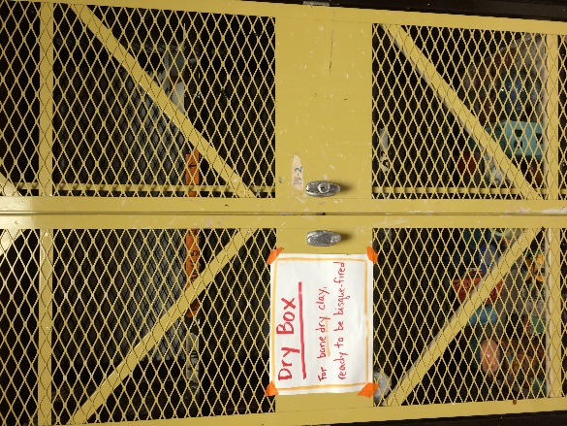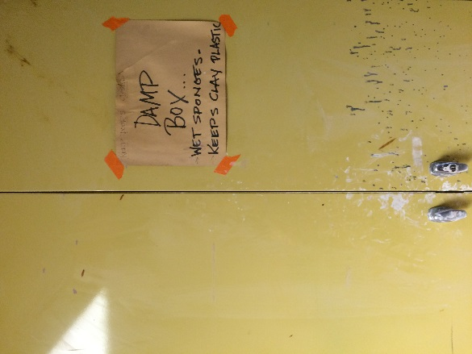
  - Finished (leather hard work) goes into dry box. Use draped plastic to slow drying time.
  - Bone dry pieces that are ready to be fired are placed on cart – Greenware shelf – Warning bone dry clay is very fragile!
  - When pieces come out of kiln they will be placed on Bisque shelf
  - Bisque work needs to be glazed and placed on Glaze shelf
  - When glazed pieces come out of the kiln they will be placed on the “to be Fired” shelf
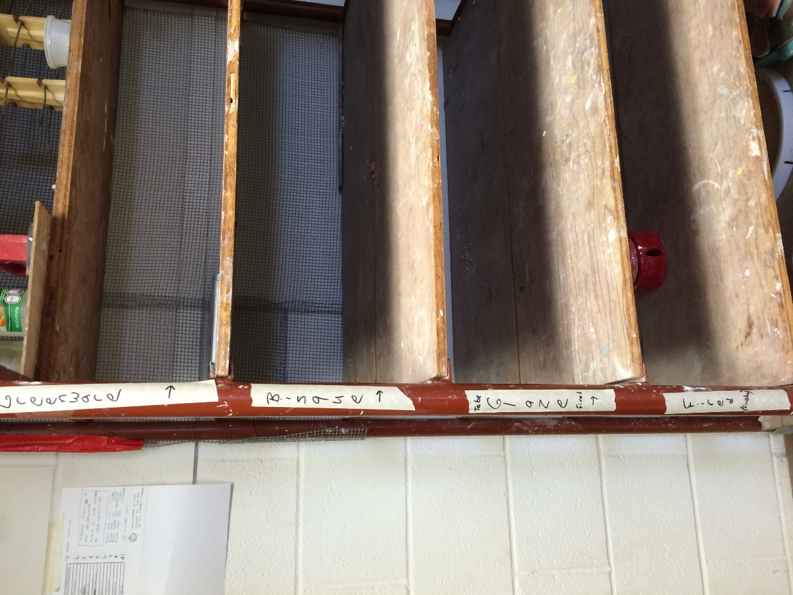

Make sure you are placing work on the proper shelf to ensure you don’t get left out of a firing.

